AWS CREDENTIALS MANAGEMENT

=====================================================================================

CREATE USER

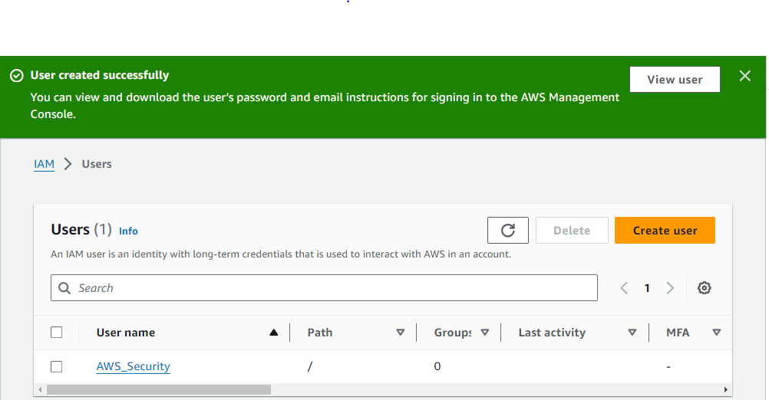

CREATE ROLE

Select trusted entity

* **AWS serviceAllow** AWS services like EC2, Lambda, or others to perform actions in this account.
* **Use case**
* EC2 Allows EC2 instances to call AWS services on your behalf.

NEXT

ADDING PERMISSIONS



* Give permission - [AdministratorAccess](https://us-east-1.console.aws.amazon.com/iam/home?region=us-east-1#/policies/details/arn%3Aaws%3Aiam%3A%3Aaws%3Apolicy%2FAdministratorAccess)
* Give role name – Dev-Ops
* Create Role

Enable Trust-relation for user under the role – ADD USER_ARN IN AWS

{

"Version": "2012-10-17",

"Statement": [

{

"Effect": "Allow",

"Principal": {

"AWS": "arn:aws:iam::112365962865:user/AWS_Security"

},

"Action": "sts:AssumeRole"

}

]

}

Create Access Key

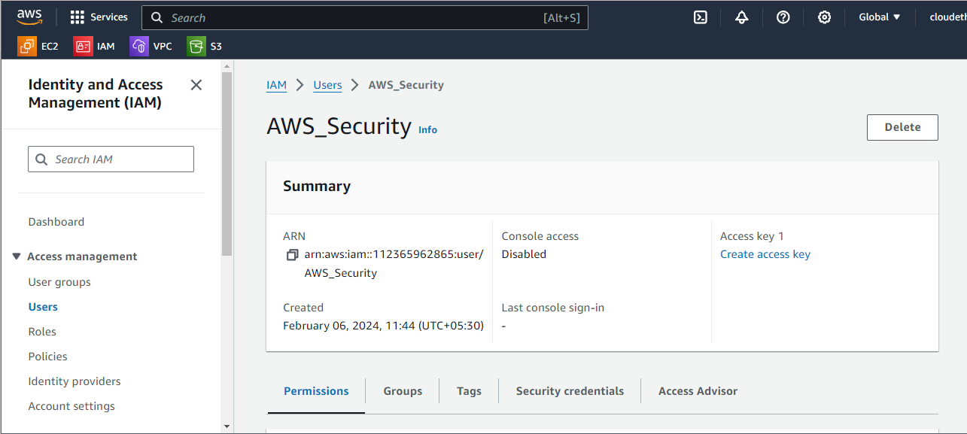

Select CLI (Command Line Interface)

Download Credentials

ON-TERMINAL

=======================

Now move our old credential in /opt

root@DESKTOP-DA2RDP0:~# cd /root/.aws/

root@DESKTOP-DA2RDP0:.aws# ll

total 16

drwxr-xr-x 2 root root 4096 Dec 28 11:13 ./

drwx------ 16 root root 4096 Feb 6 11:36 ../

-rw------- 1 root root 43 Jan 23 11:48 config

-rw------- 1 root root 116 Jan 23 11:48 credentials

root@DESKTOP-DA2RDP0:~# mv .aws/ /opt

-----------------------------------------------------

put new access credentials

-----------------------------------------------------

root@DESKTOP-DA2RDP0:~# aws configure

AWS Access Key ID [None]: AWS Access Key

AWS Secret Access Key [None]: AWS Secret Access Key

Default region name [None]: us-east-1

Default output format [None]: json

root@DESKTOP-DA2RDP0:~#

* Add roles arn in –role-arn

root@DESKTOP-DA2RDP0:~# aws sts assume-role --duration-seconds 900 --role-arn "arn:aws:iam::112365962865:role/Dev-Ops" --role-session

-name security-role-session

{

"Credentials": {

"AccessKeyId": " Add your AccessKeyId ",

"SecretAccessKey": "Add your SecretAccessKey ",

"SessionToken": "Add your SessionToken”

"Expiration": "2024-02-06T06:57:10Z"

},

"AssumedRoleUser": {

"AssumedRoleId": "AROARUKMIQZYQIM6QH6QW:security-role-session",

"Arn": "arn:aws:sts::112365962865:assumed-role/Dev-Ops/security-role-session"

}

}

root@DESKTOP-DA2RDP0:~#

Export the credentials and use it

export AWS_ACCESS_KEY_ID=" Add your AWS_ACCESS_KEY_ID "

export AWS_SECRET_ACCESS_KEY="Add your AWS_SECRET_ACCESS_KEY "

export AWS_SESSION_TOKEN= "Add your AWS_SESSION_TOKEN"

CREATING AWS BUCKET

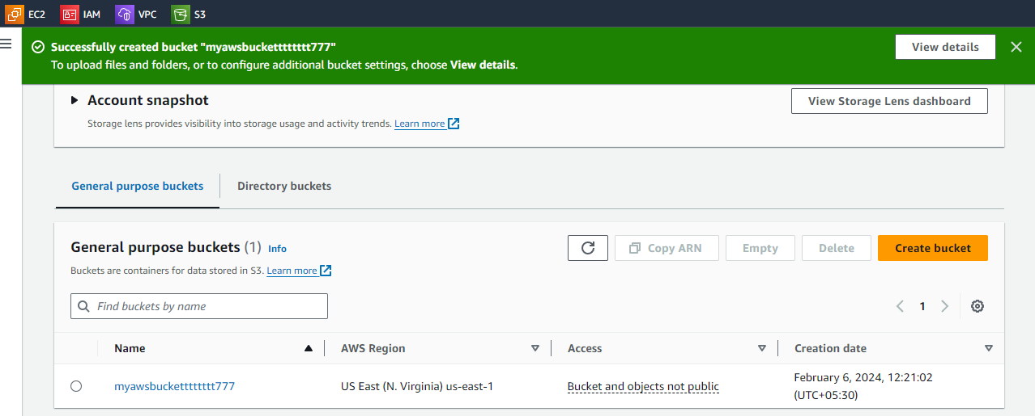

root@DESKTOP-DA2RDP0:~# aws s3 ls

2024-02-06 12:21:02 myawsbucketttttttt777

root@DESKTOP-DA2RDP0:~#